

**Cohesity**

**Plugin Configuration Guide**

Contents

Cohesity Configuration Checklist 2

Supported Collection Types 2

Data Sources 2

Requirements 3

Cohesity Ports 3

Setup 3

Server Properties 3

Field Definitions 3

Troubleshooting 4

Problem: Cannot collect data for past backup jobs. 4

Technical Support 5

# Cohesity Configuration Checklist

Detailed configuration steps are below, this checklist is an overview of the steps to configure Cohesity collections on your Bocada Data Collection Server:

* Verify username & password for Cohesity API access (the username provided must have at least Viewer level access).

# Supported Collection Types

The plugin, in its Beta format, currently supports the following collection types from Cohesity servers:

|  |  |  |
| --- | --- | --- |
| **Collection Type** | **Supported** | **Description** |
| Backup* | ✓ | Collects transactional details about backup, duplication and restore jobs. Example metrics include, start times, durations, bytes, files, errors etc. This includes In Progress jobs. |
| Storage | ✓ | Collects point-in-time inventory information. Example metrics include, total recoverable gigabytes (storage), media volume count, media volume status, etc. |
| Policy |  | Collects and stores information on policy attributes, schedules, storage units, storage groups, storage lifecycle policies and clients. |
| In Progress | ✓ | Collects basic information on backups that are running or have completed since the previous full Backup jobs data collection. These updates are included in the Backup updates but are lightweight and can be scheduled more often than backup updates if needed. |

**\* Note:** The *VM Protection Analysis* report displays Virtual Machines (VMs) in the environment, showing data protection status (or lack thereof) for each VM, and will indicate if those VMs are protected by snapshots, backup applications, or are exposed as unprotected.  This feature is supported for several backup applications, including Cohesity.

When both vCenter and Cohesity Backup Servers have been added to Bocada, Backup updates on both will also correlate Cohesity client data with vCenter virtual machine data, in the following scenario:

* The Cohesity server backup client is a virtual machine managed by vCenter.
* The vCenter virtual machines have been added to Bocada data collection and previously inventoried using the vCenter plugin in Bocada.

# Data Sources

The plugin relies on the following Cohesity data sources:

* Cohesity API

# Requirements

This section lists requirements that must be met prior to collecting data with the Bocada plugin for Cohesity.

### Cohesity Ports

|  |  |  |
| --- | --- | --- |
| **Service** | **Default Port** | **Note** |
| *HTTPS* | 443 | REST API connection through HTTPS |

# Setup

### Server Properties

Backup Server Properties determine how the plugin will interface with the Cohesity Cluster and are managed through the Backup Servers view.

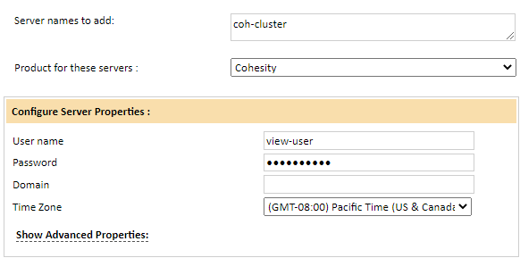

### Field Definitions

#### Server name

Enter the *Access Cluster* as the Server name.

#### User name / Password

Enter the credentials for the Cohesity user that has at least View role privileges to the *Access Cluster*.

#### Domain

Enter the user’s domain (e.g. mydomain.com) if using a domain user to collect from the *Access Cluster*. If the user is a local user on Cohesity, use “local”.

#### Time Zone

Select the time zone where Cohesity server resides. This setting ensures times are displayed consistently in environments that span multiple time zones.

# Troubleshooting

## Problem: Cannot collect data for past backup jobs.

Backup jobs whose snapshot data has expired cannot be mined by Bocada due to missing data required for valid jobs. The jobs outlined in red below cannot be mined.

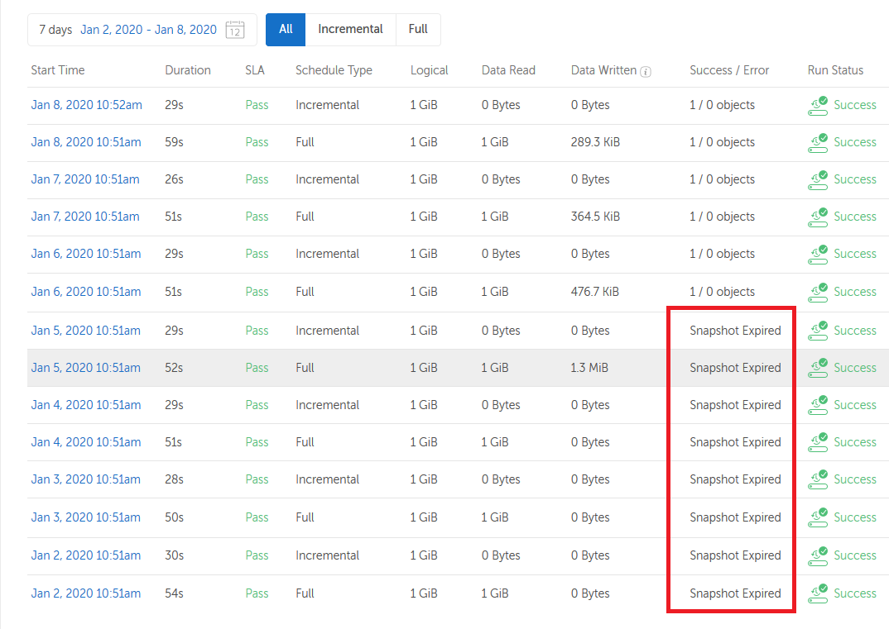

# Technical Support

For technical support or a copy of our standard support agreement, please contact us.

**E-mail:** [support@bocada.com](mailto:support@bocada.com)

**Support Portal:** <https://bocada-support.force.com>

**Phone:** +1-425-898-2400